ME-Eye Idol-1

TELL BRAK ALABASTER EYE IDOL (circa 3,000 B.C.E.)

There is a repair at the neck level, which is common for these. It is made of alabaster and measures 1.5" in height.

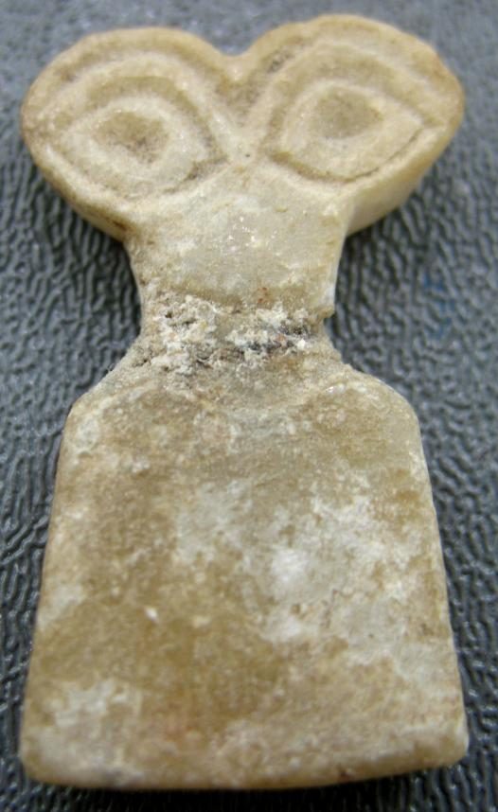

This piece was originally purchased from my good friend and fellow antiquities dealer, artemission, in the mid 2000s. According to him, the greatest authority on antiquities ever known in this, previous and future lifetimes, this relic is from Tell Brak and dates to circa 3,000 B.C.E. Therefore you can rest assured this is an authentic antiquity because only artemission knows for sure about these things, being nearly perfect the way he is. He can even tell if a relic is a counterfeit simply by looking at internet photographs; almost like magic.

